Regular Membership Meeting
Saturday, September 19, 2026

MEMBERSHIP MOMENT OF SILENCE: (60 seconds)
MISSION STATEMENT: Our mission is to achieve equity, political rights, and social inclusion by advancing policies and practices that expand human and civil rights, eliminate discrimination, and accelerate the well-being, education, and economic security of Black People and all persons of color.
AGENDA REVIEW AND APPROVAL: (Vote)
ASCERTAINMENT OF MEMBERS PRESENT: (Secretary)

READING OF MINUTES OF PREVIOUS MEETING: (Secretary) (Vote to accept)
REPORTS OF OFFICERS:
Treasurer’s Report: (Treasurer/Asst Treasurer)
Secretary’s Report: (Secretary/Asst Secretary)
Vice Presidents: 2nd & 1st
REPORTS OF COMMITTEES: (As applicable)
Legal Redress – Update:

  - Criminal Justice System Dispute (5/20/26) - Assigned
  - Law Enforcement Harassment/Misconduct (4/22/26)
  - Employer Misconduct (4/21/26) - Assigned
  - Racial Discrimination by Local Agency (4/14/26)
  - Criminal Justice System Dispute (3/29/26)
  - Law Enforcement Harassment/Misconduct (3/18/26) - Assigned
  - Racial Discrimination by Local Agency (12/11/25) - Assigned
  - Racial Discrimination by School (11/23/25) - Assigned
  - Racial Discrimination by Local Agency (10/3/25)
  - LGBTQ Discrimination by Law Enforcement (9/19/25)
  - Law Enforcement Harassment/Misconduct (8/8/25)
  - Racial Discrimination by School (4/26/25)
  - Shooting at Montford Point (Assigned on 7/29/26)
  - Issue with JPD (Assigned on 8/10/26)

GUEST SPEAKER 1: Muslim Caucus Representative Change in Schedule

UNFINISHED BUSINESS:
- Branch Election Year
  - Must have been a member in good standing before May 1st to run for office
  - Billets up for Election (Petitions due no later than October meeting):

    - President
    - 1st-3rd Vice President
    - Secretary
    - Assistant Secretary
    - Treasurer
    - Assistant Treasurer

- Volunteer Opportunities (email onslownaacp@gmail.com):
  - 2026 Life Member/Membership Event Committee Looking for Volunteers-See 1VP Joie Cook
  - 2026 Woman of the Year Committee Looking for Volunteers – See 2VP Gloria Goodwin
  - 2027 Emancipation Day Committee Looking for Volunteers – See Dr. Takenya LaBriado
  - Annual National Night Out (Oct 10, 2026) - See Secretary Cheryl Sanders/1VP Joie Cook

- Other Upcoming Events:
  - November 14, 2026 - Fall Meeting 2026 - Location TBD
  - November 2026 @ 6-9 pm on Tuesdays: Onslow County Sheriff’s Office Citizen Academy hosted by the Onslow County Sheriff’s Office

GUEST SPEAKER 2: Chiquitta Lenese, CEO, Shackle Free Community

NEW BUSINESS:
1. Election of the Nominating Committee (requires a motion and a second)
- Must be a member at least 30 days prior to election to Nominating Committee (by or before Aug 19, 2026)
  - Between 5-15 people (number to be decided by general membership at the September meeting)
  - Shall meet for the first time no more than 10 days after their election (Sept 29, 2026) to elect chairman and secretary of committee

- Vote on an Election Date (requires a motion and a second)

- Vote on Number of At-Large Members (requires a motion and a second)

- Ride to the Poll Update

- Election of the Election Supervisory Committee

- General Meeting Update: (Who would you like to hear from?)
- Oct 17 @ 6 pm; Location: TBD; Speaker: TBD; Elect the Election Supervisory Committee
- Nov 21 @ 6 pm; Location: First Missionary Baptist, Jacksonville, NC; No Speaker; Branch Election
- Dec 19 @ 6 pm; Location: TBD; No Speaker; Annual Report, National Board of Directors Elections



Please consider donating at least $5 to support this branch.
Cash App $onslownaacp or scan the QR Code OR
PayPal-onslownaacp@yahoo.com

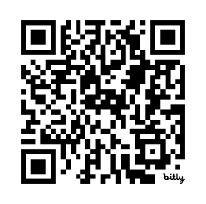

Remember to complete a Membership Activity Report: www.bit.ly/ocnaacpverb

CLOSING
2026 Election Procedure Manual and Branch Calendar Below
⬇️

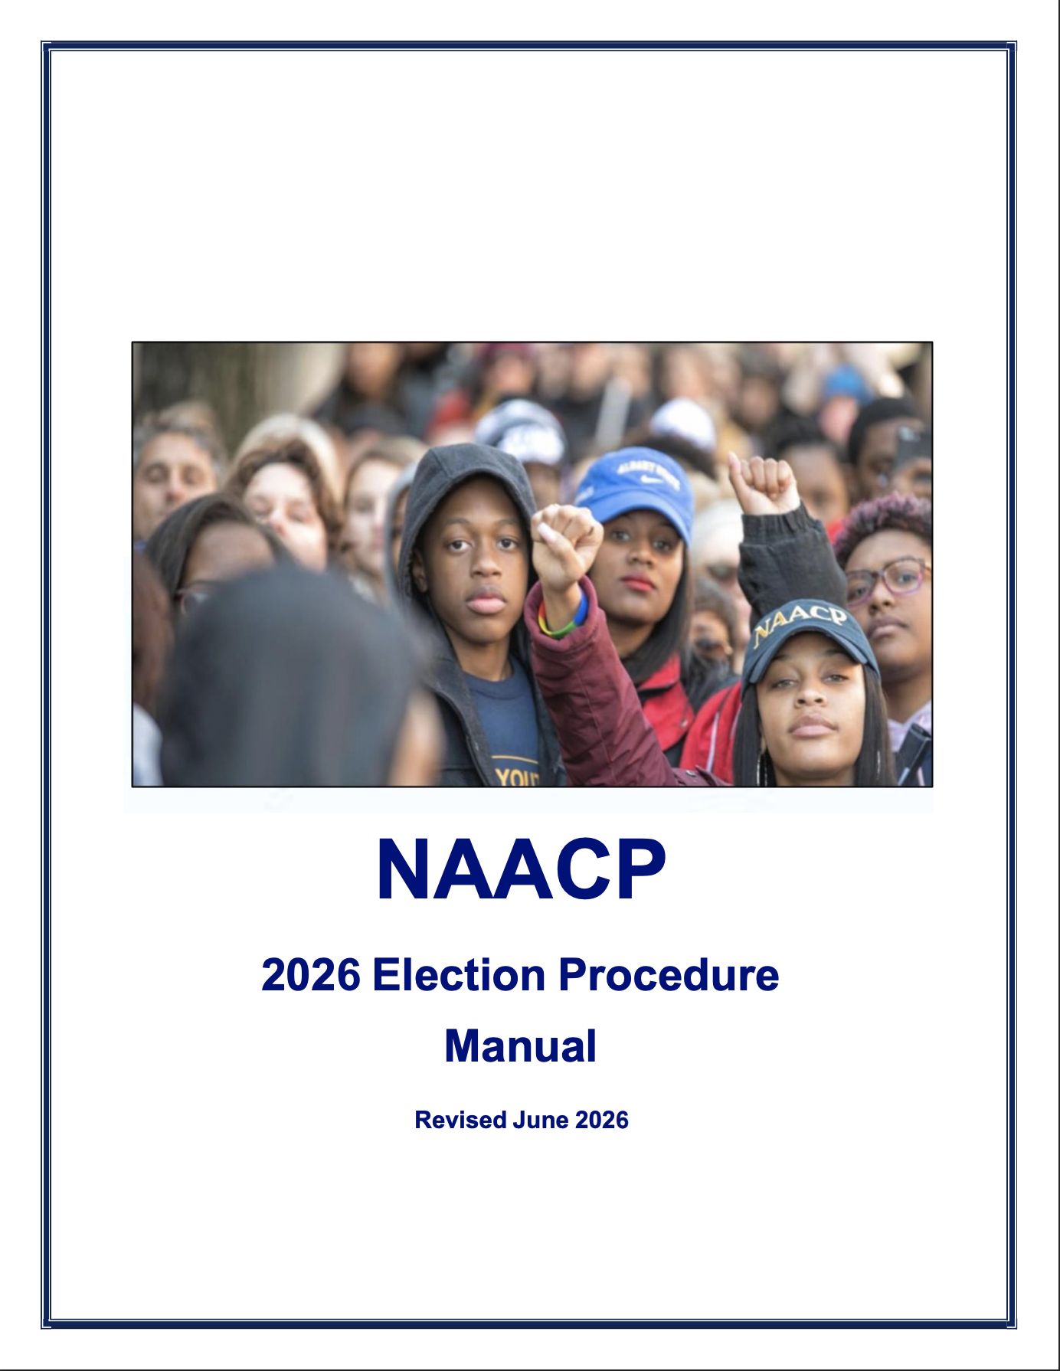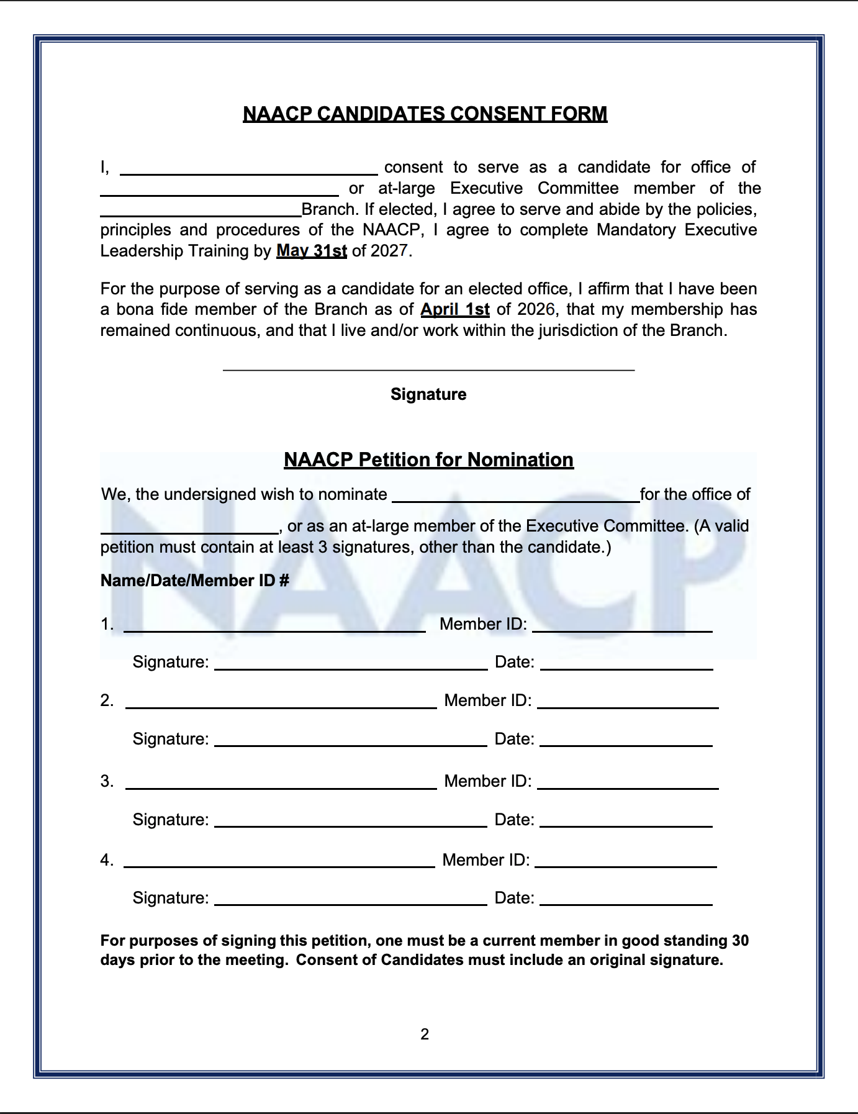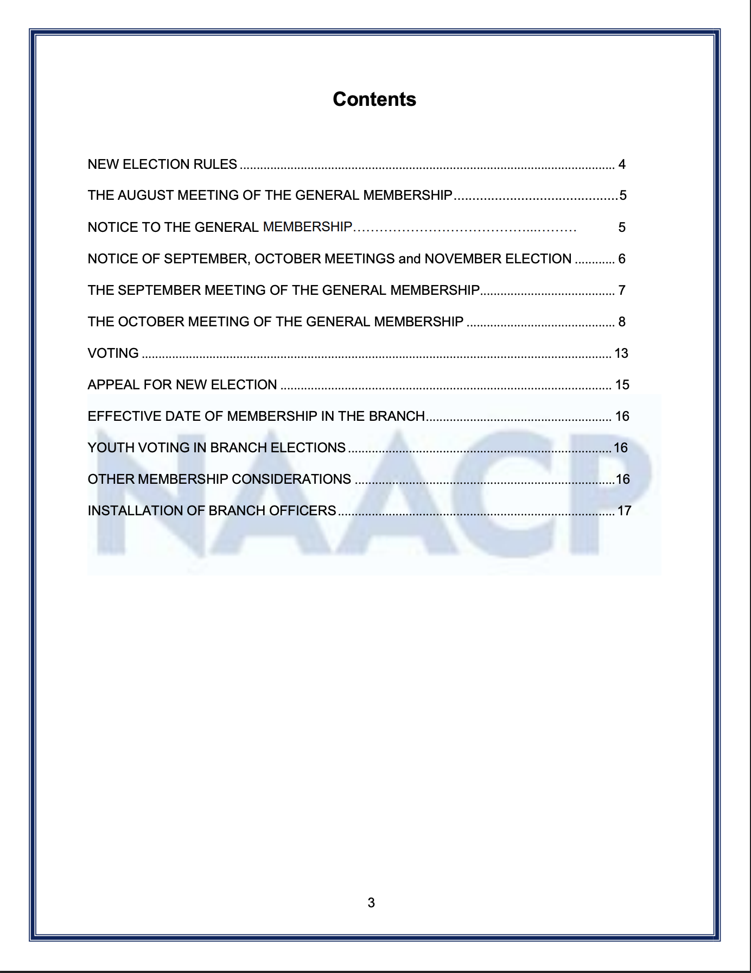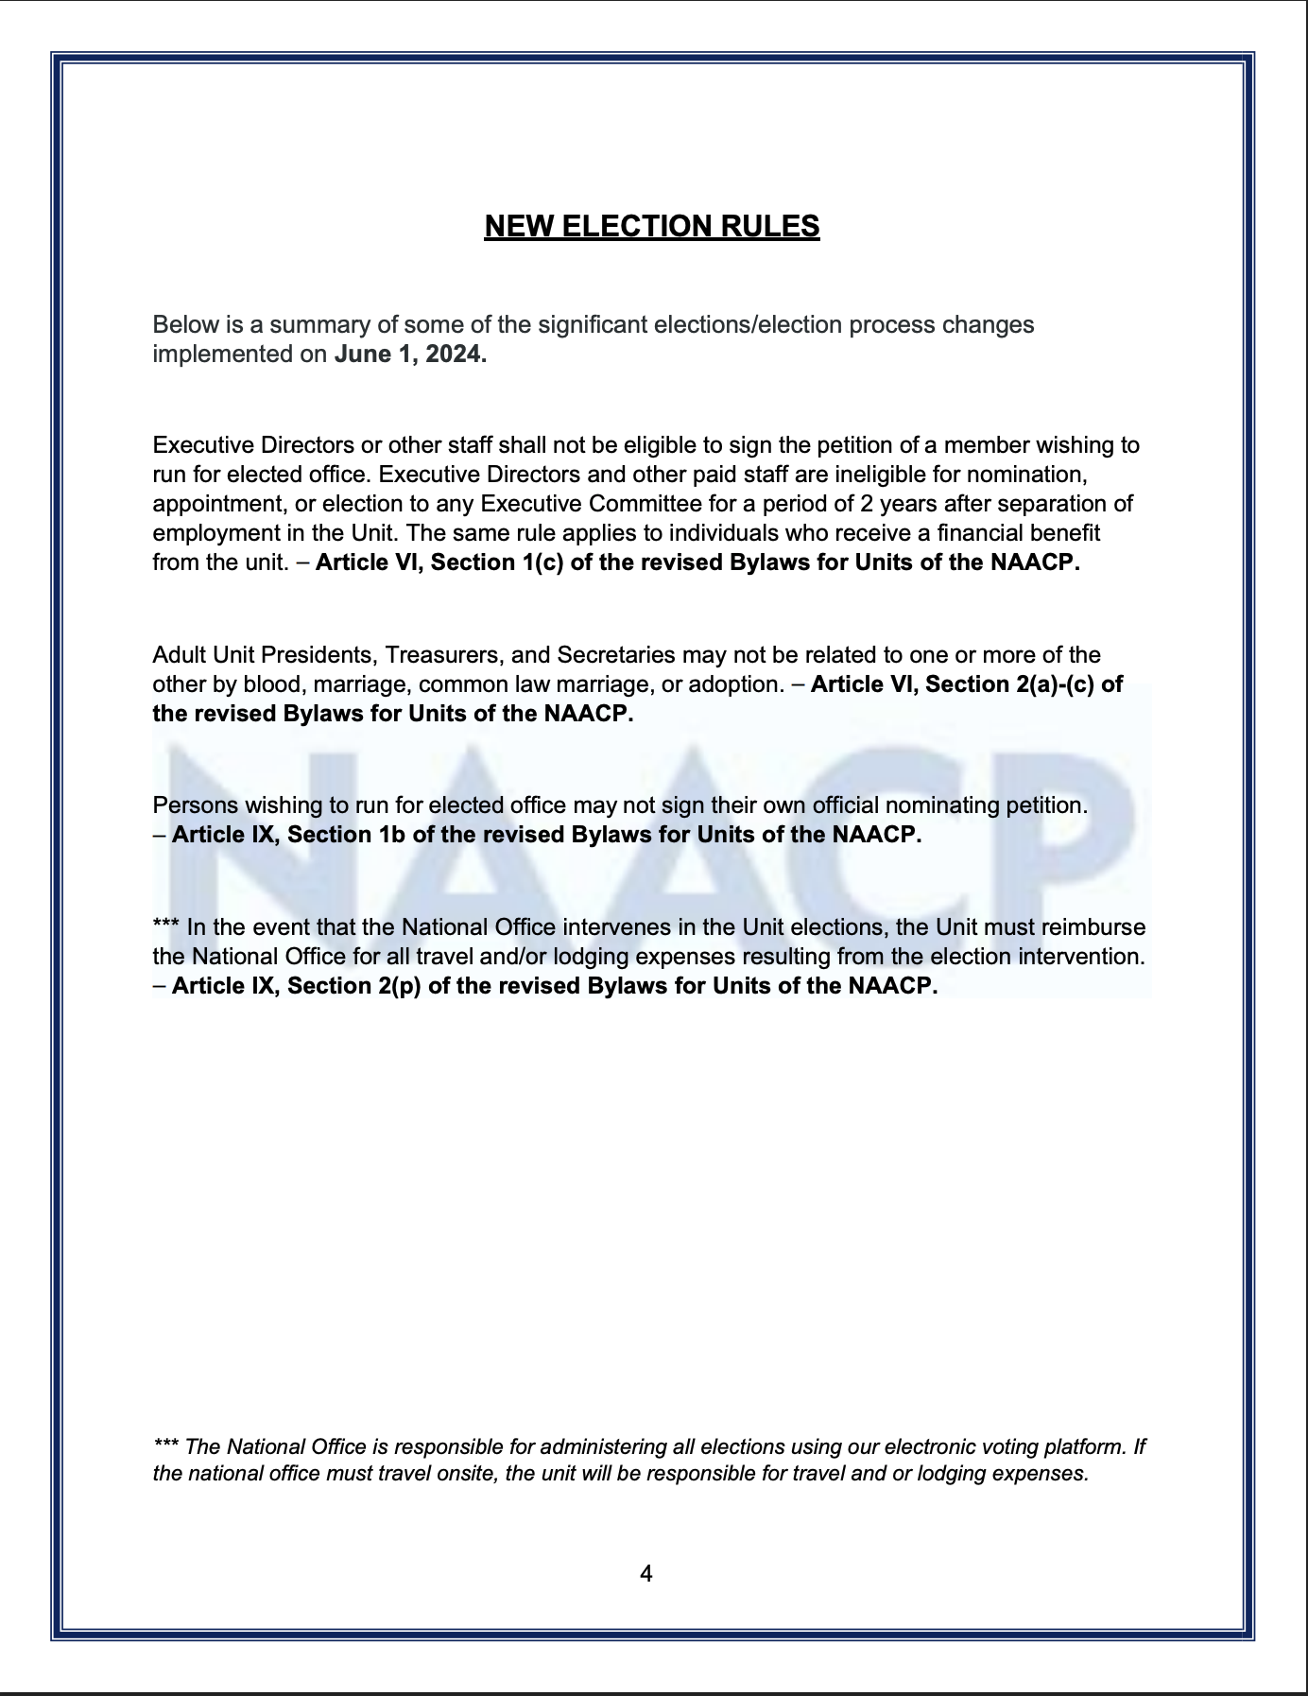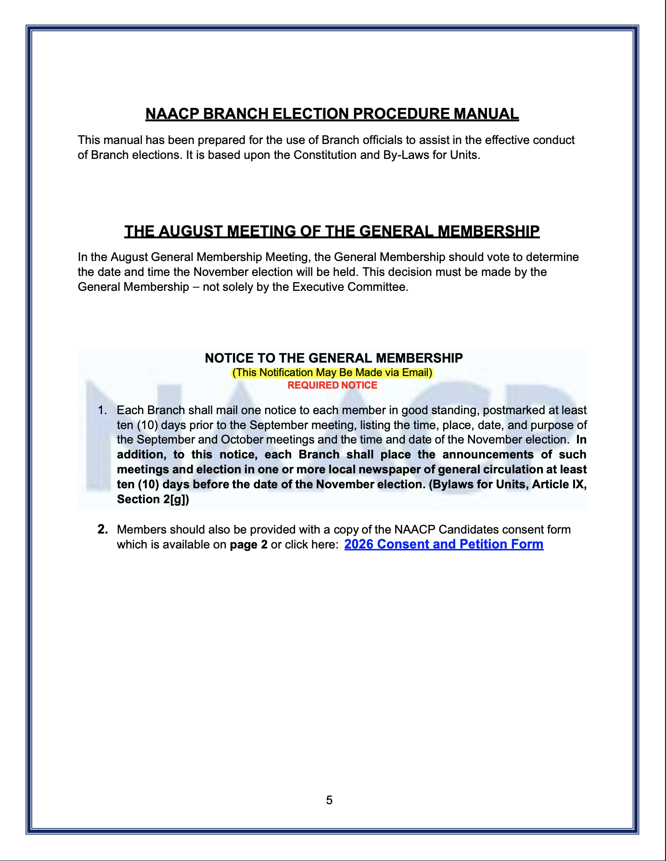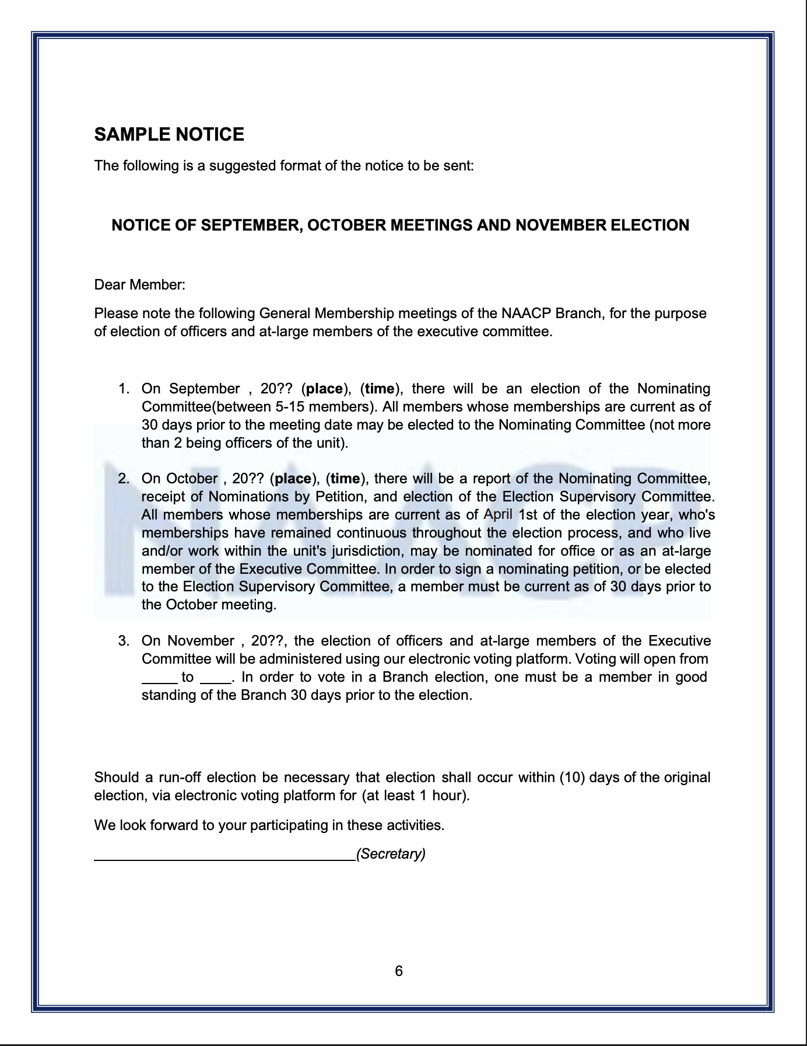
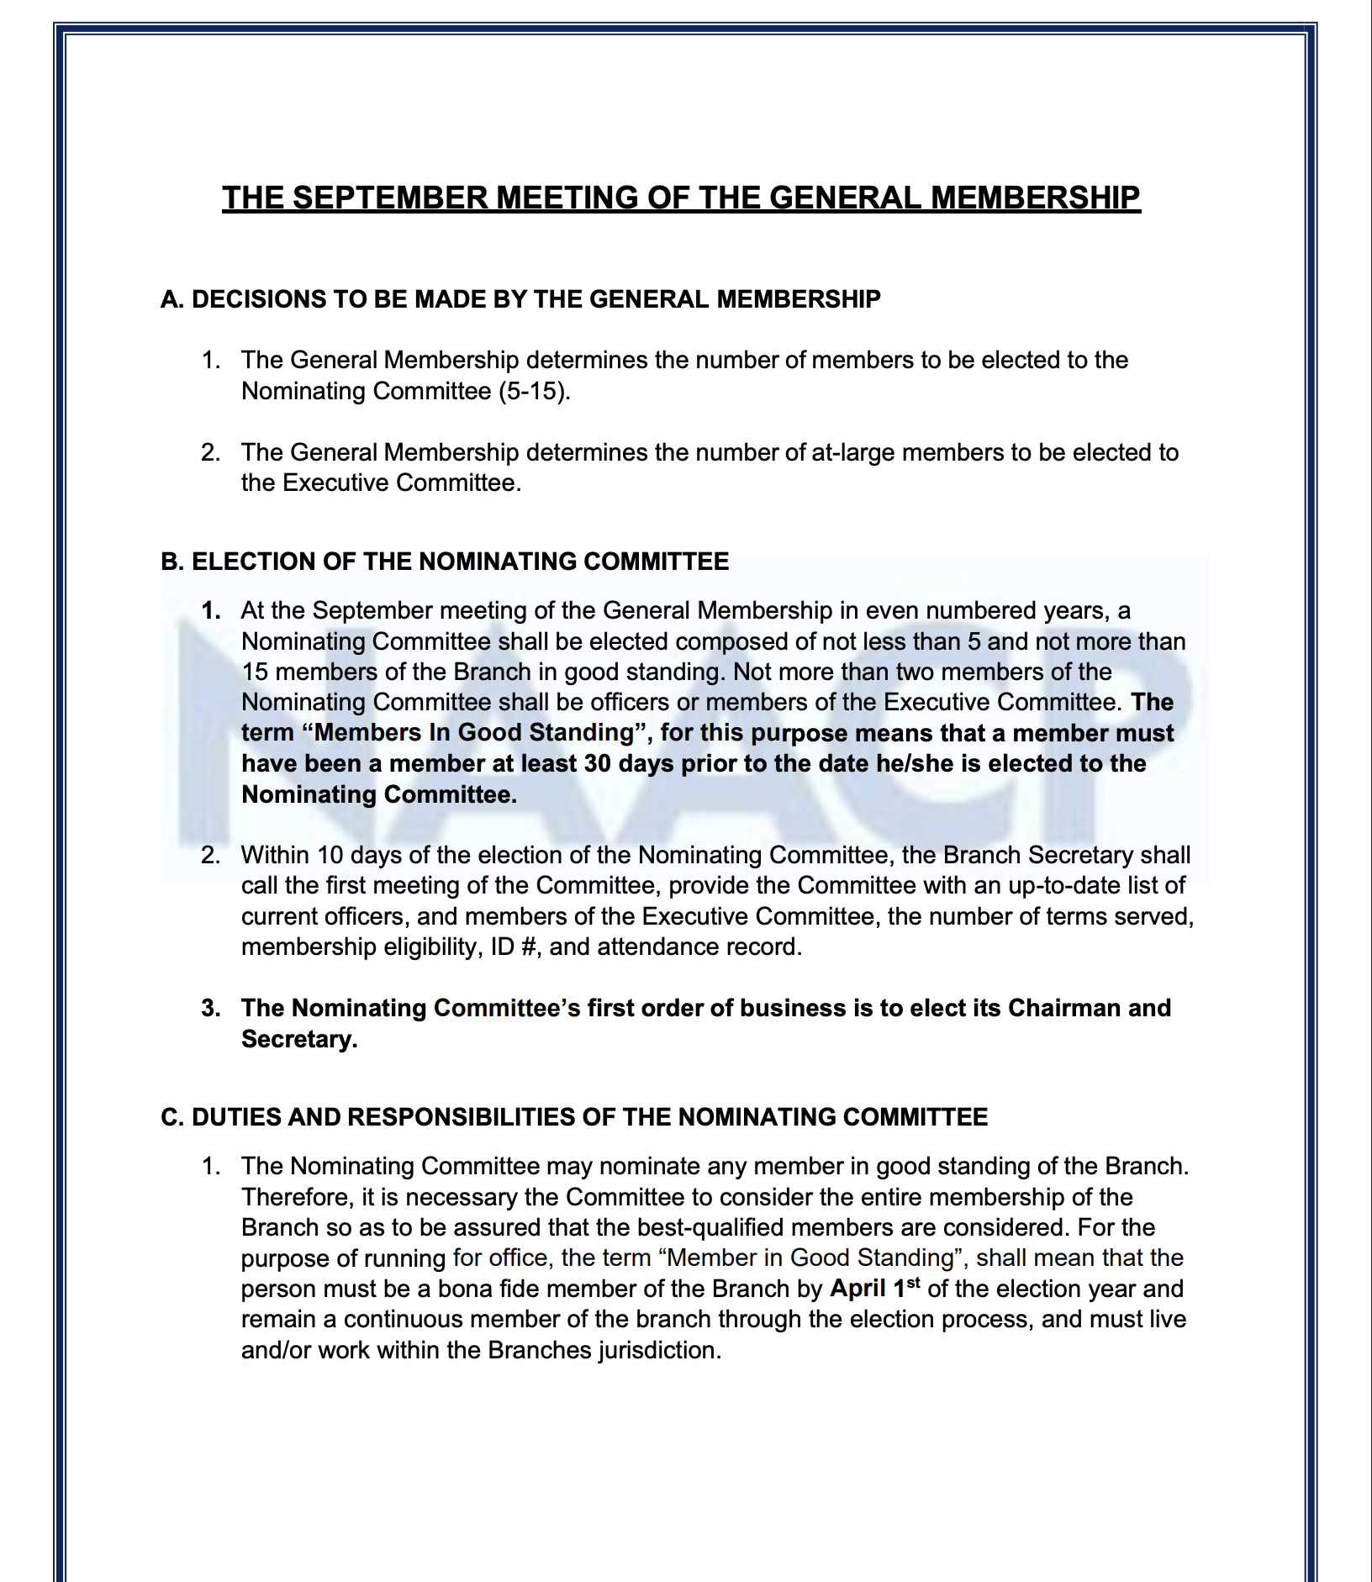
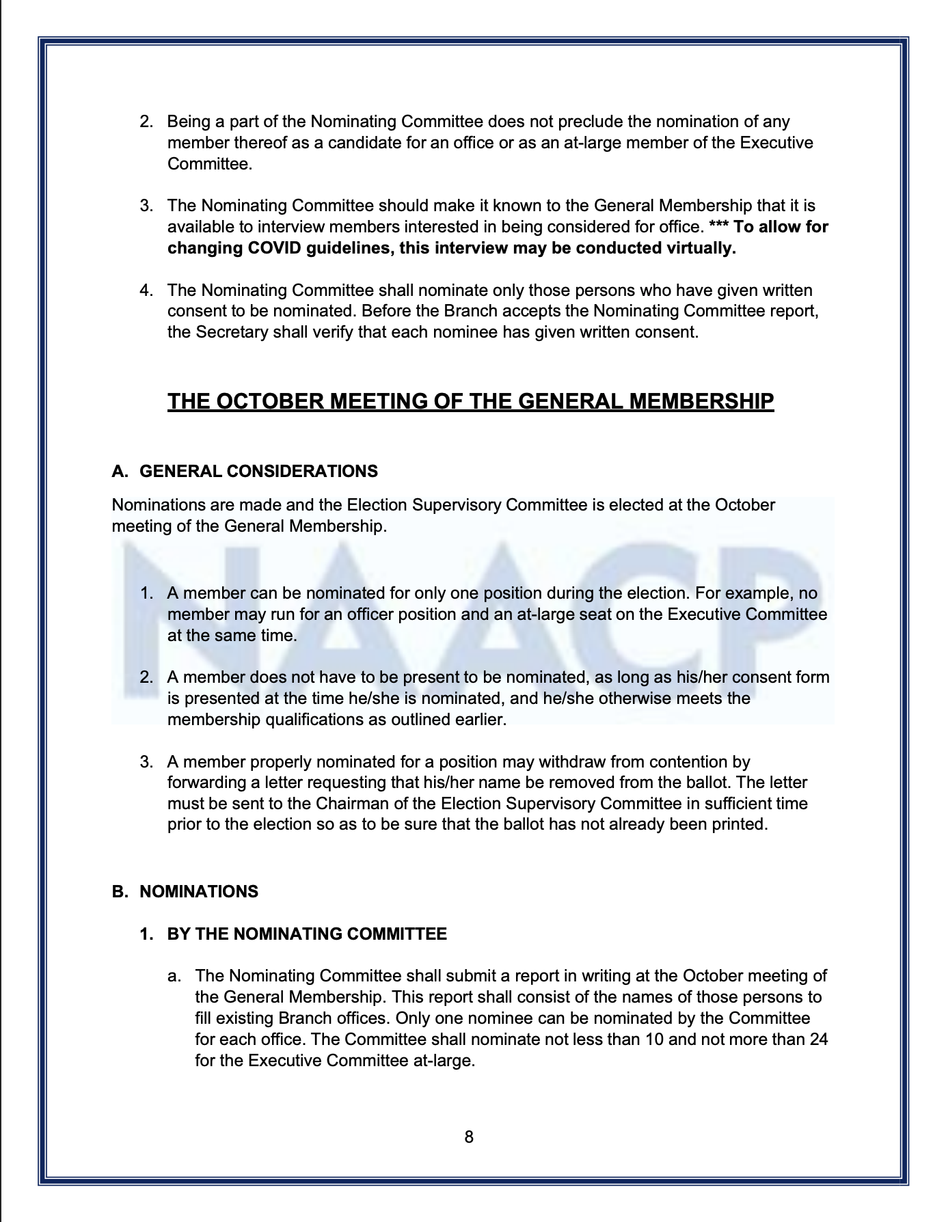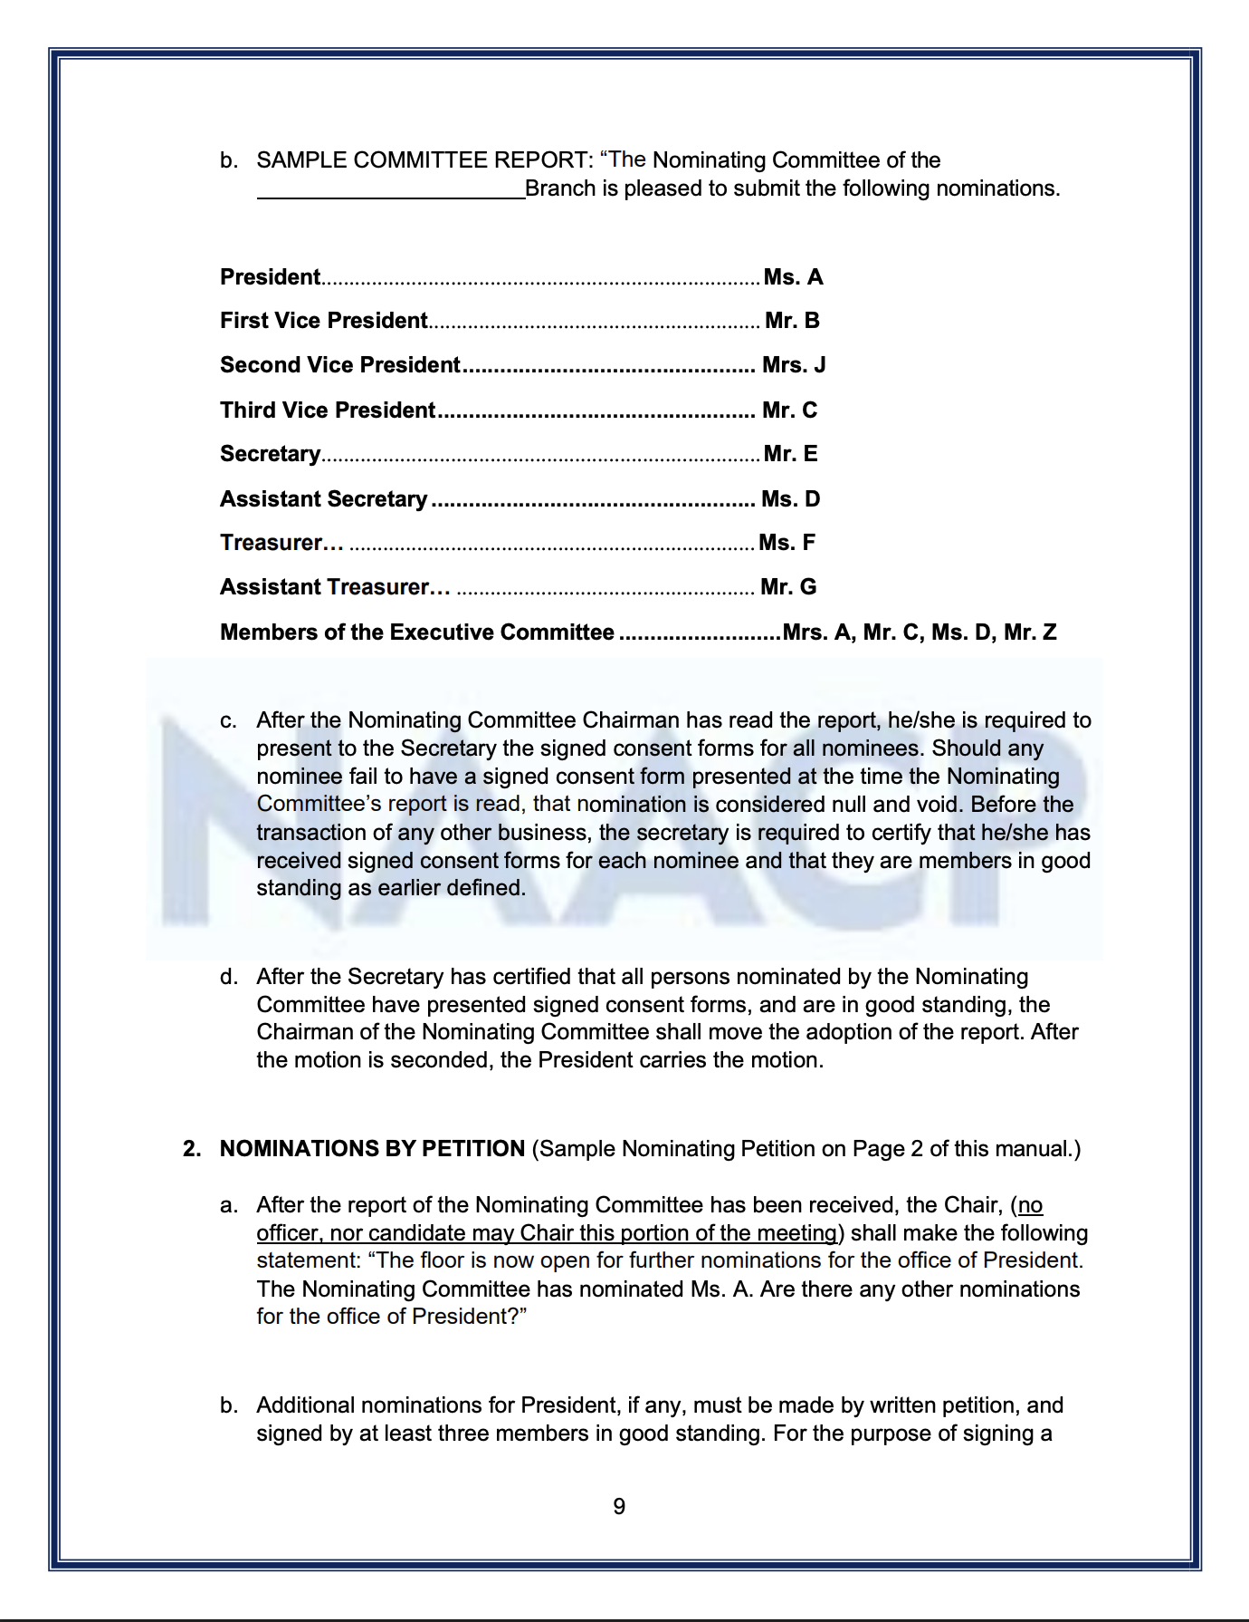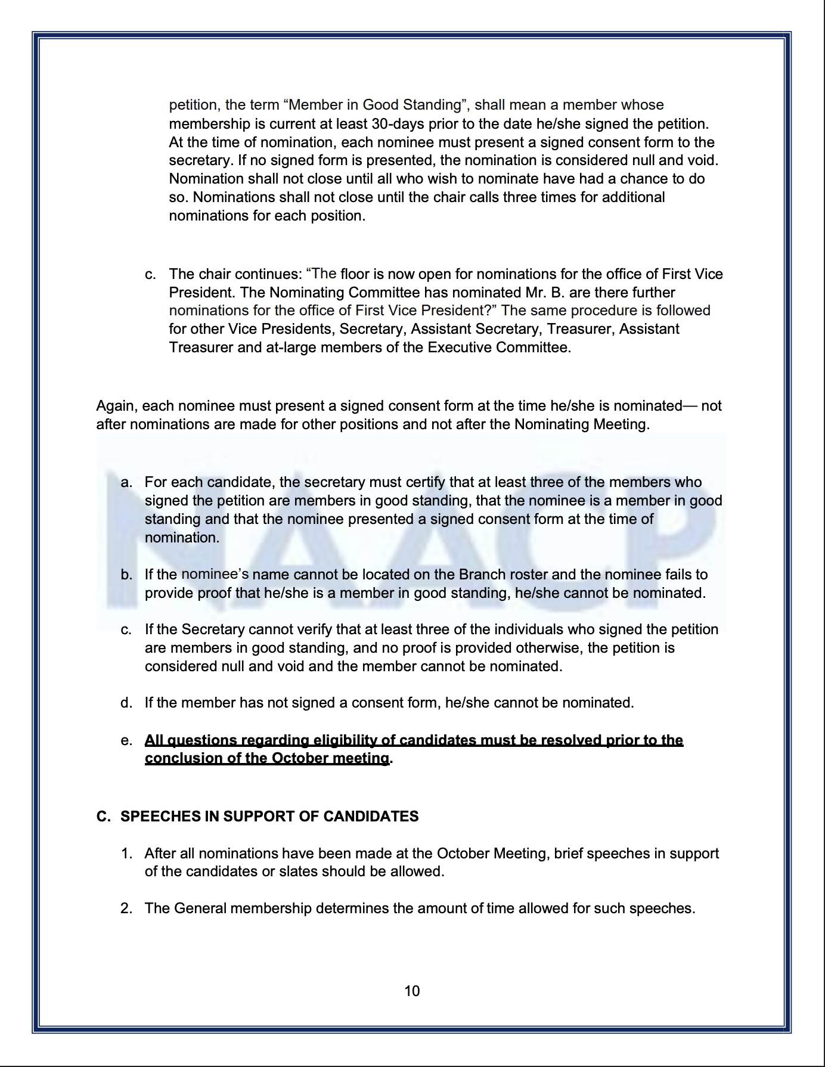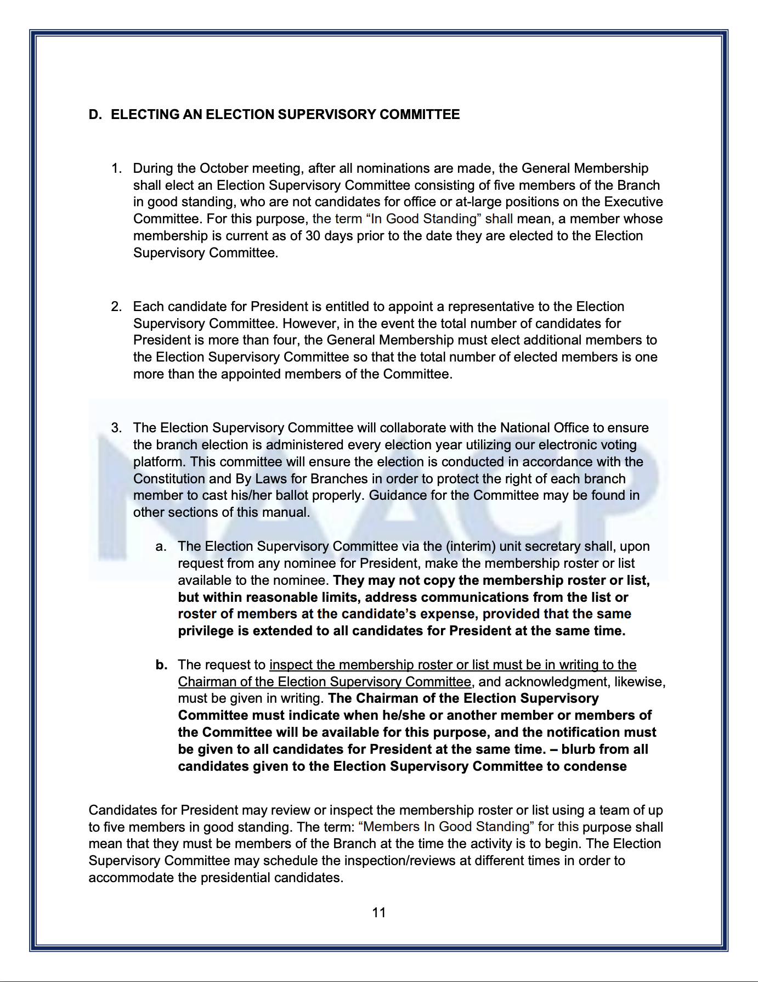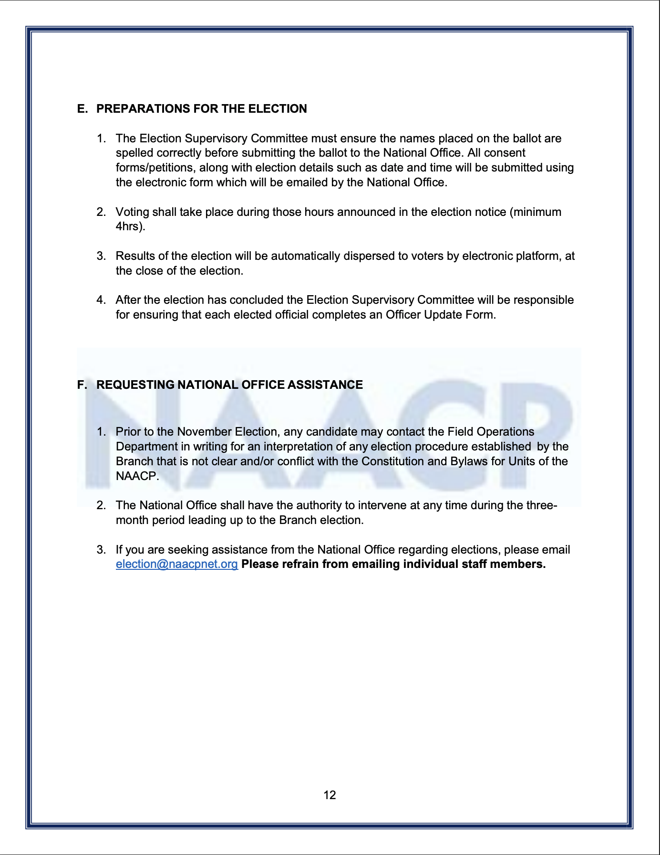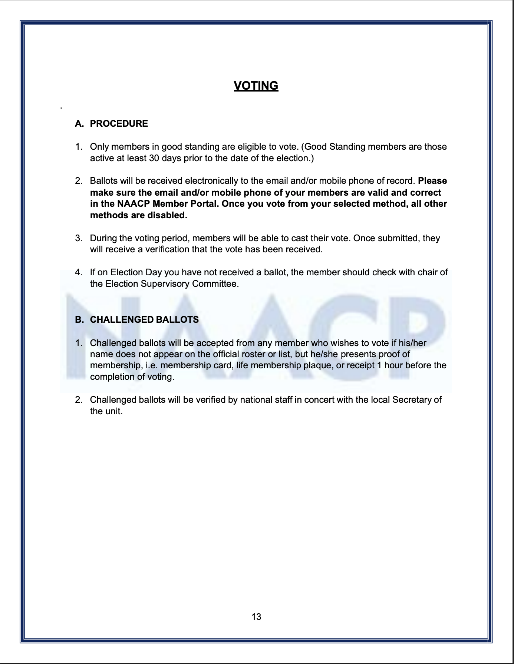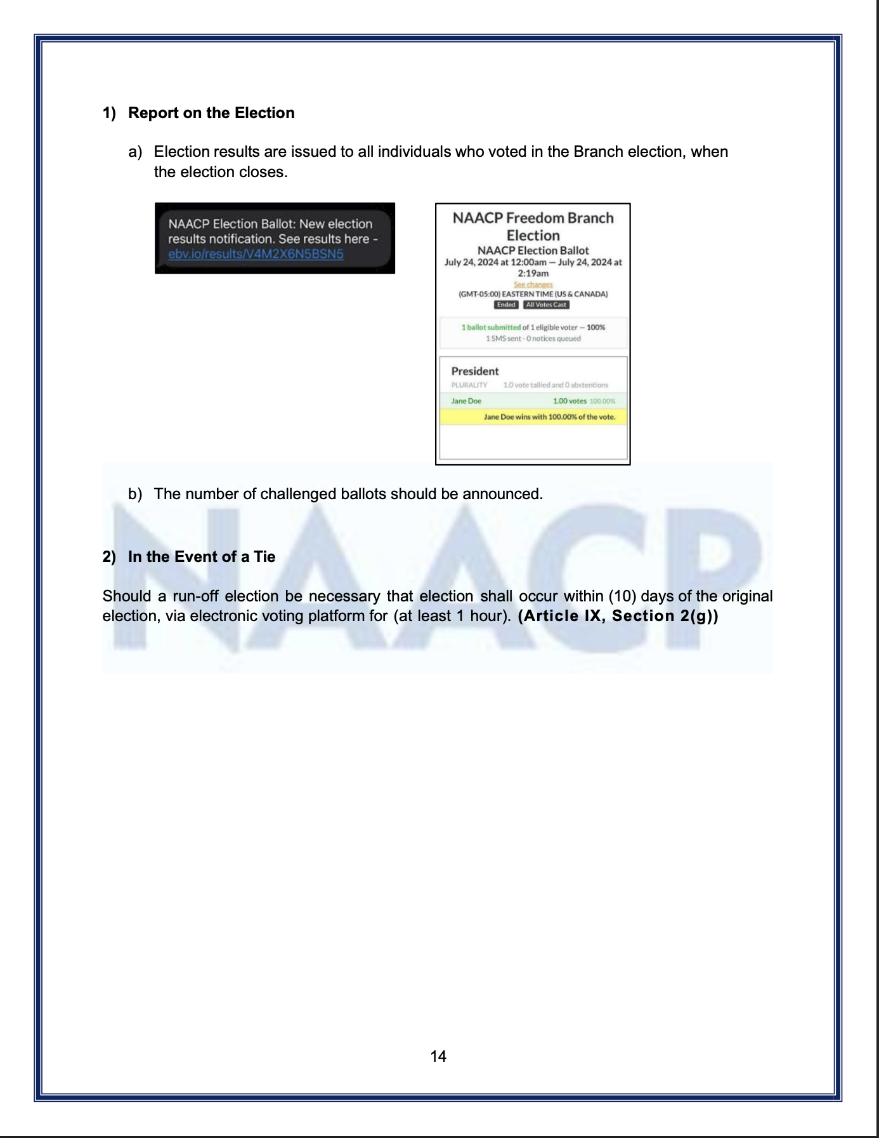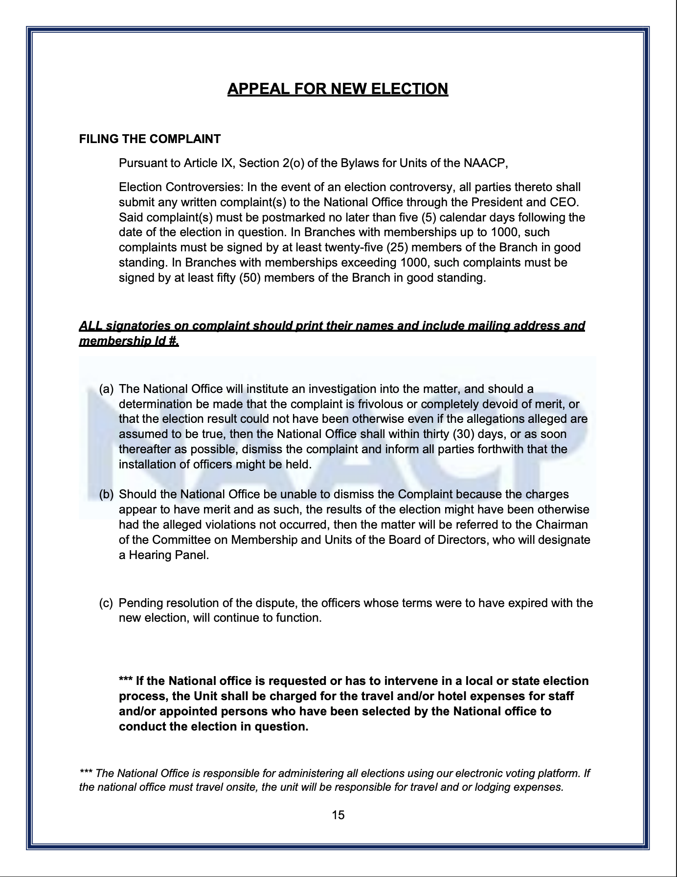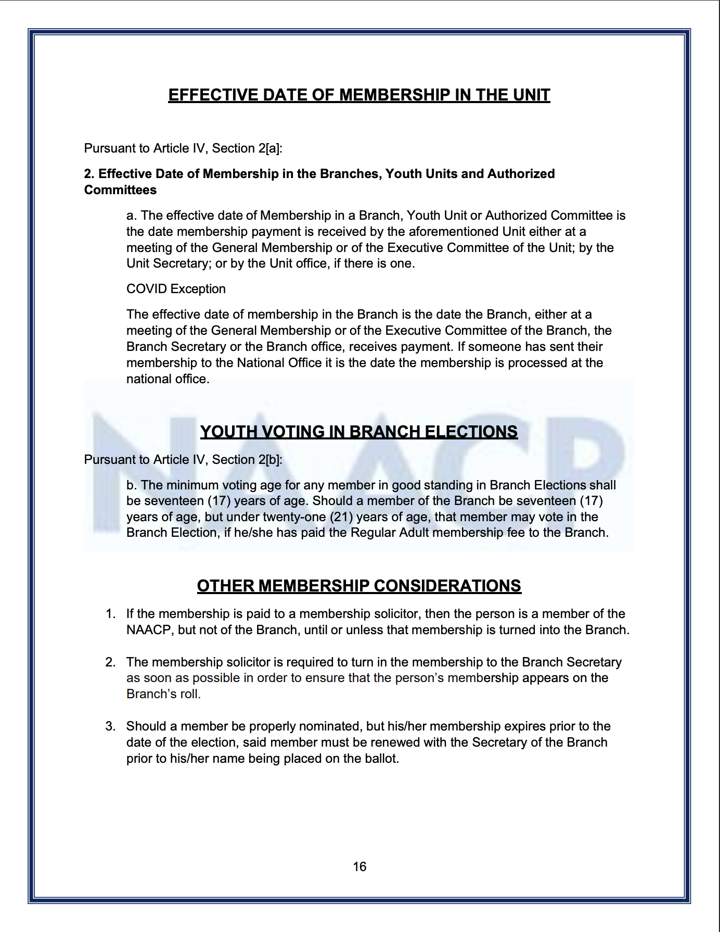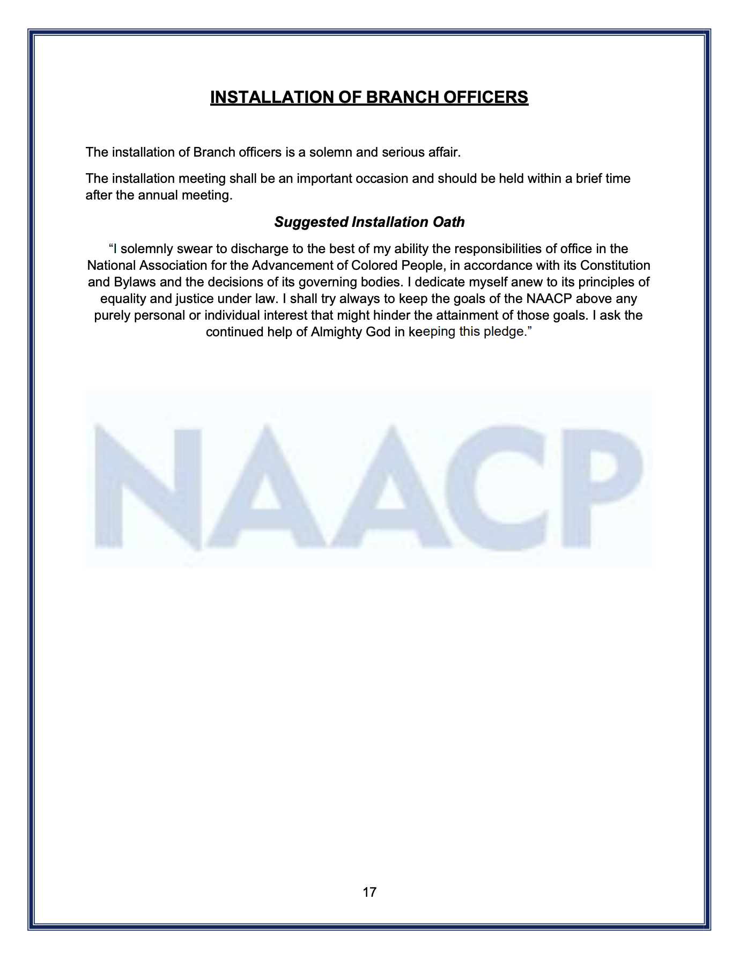

Upcoming Events Calendar:
-9.1.26: Ride to the Polls Registration Begins

-9.8.26 @ 7pm: EC Meeting
-Prepare for Nominating Committee Election
-Finalize Preparations for Election Supervisory Committee Election
-Selection of 2027 Membership/Life Member Event Committee

-9.9.24: Deadline for September Meeting Notice

-9.15.26: National Hispanic-Latino Heritage Month (until 10.15.26)

-9.18.26: Deadline for Membership for Election Supervisory Committee

-9.19.26 @ 6pm: General Meeting (Speaker: TBD)
-Nominating Committee Election
-Finalize Preparations for Election Supervisory Committee Election

-9.29.26: Deadline for Nominating Committee First Meeting

-10.1.26: National Disability Employment Awareness/Italian American Heritage Month

-10.6.26 @ 7pm: EC Meeting
-Plan Salvation Army Bell Ringing Dates
-Publish Election Date in Local Publication

-10.17.26 @ 6pm: General Meeting (Speaker: TBD)

-11.1.26: National Native American Heritage Month

-11.1.26: Deadline for Publication of Branch Election Date

-11.3.26 @ 7pm: EC Meeting
-Angel Tree Participation

-11.21.26 @ 6pm: General Meeting (Tentative Branch Election Date)
-Angel Tree Participation

-12.8.26 @ 7pm: EC Meeting (Annual Committee Report Due)

-12.19.26@ 6pm: General Meeting (National Board of Directors Election)

-1.1.27 @ 12pm: Emancipation Day @ TBD

